Polygon
# Source: AI Source: Provided by: [Data Path: Persons Table -> ID Column: 1, Name_En Column: Motasem Essam] -> From: [ChatGPT] on [7/25/2026]
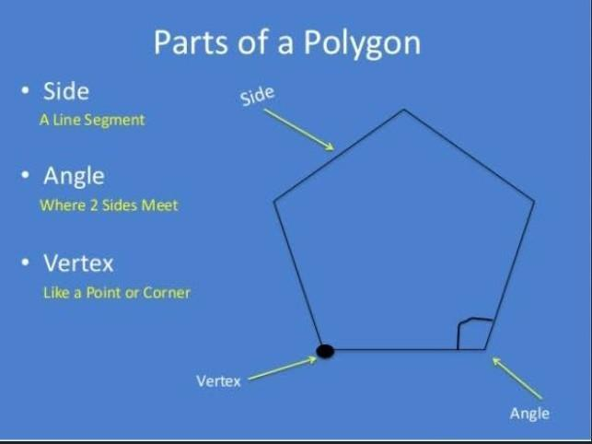
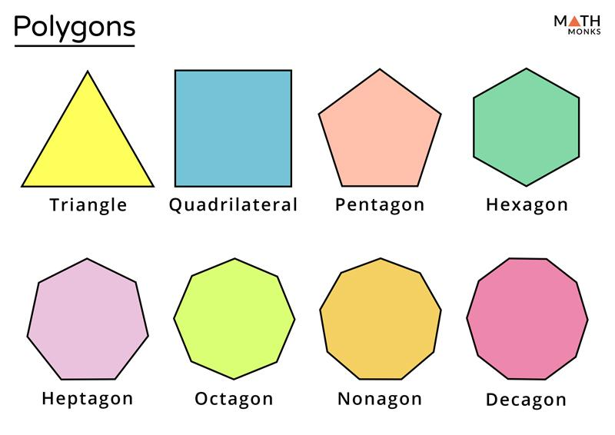
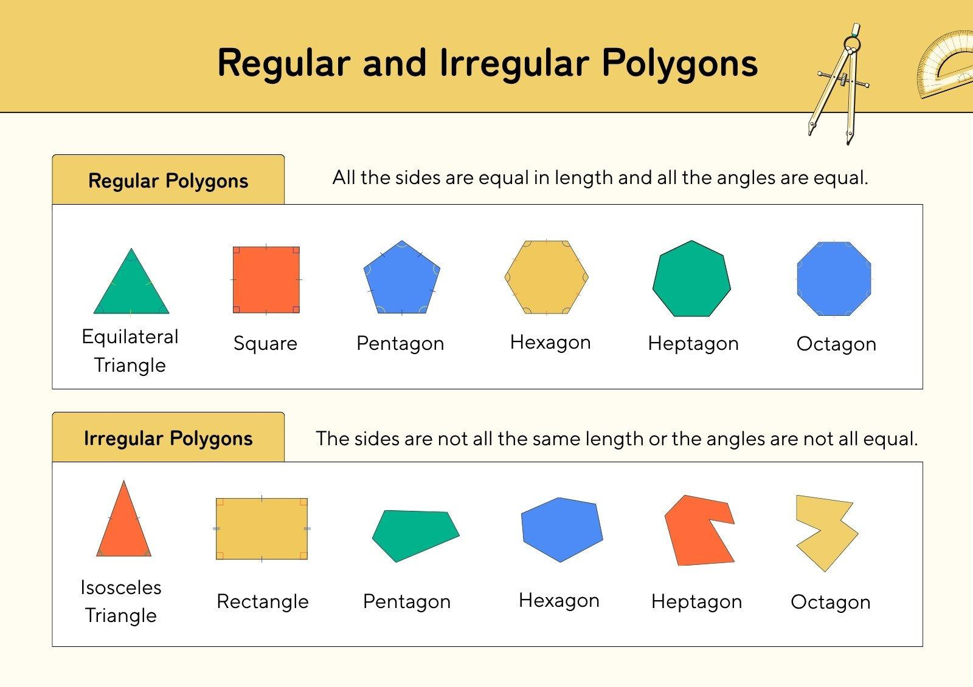
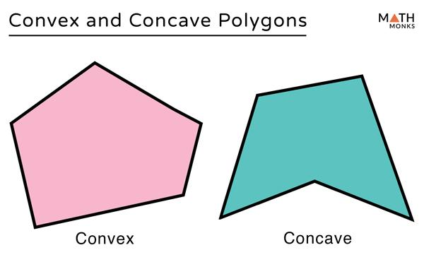
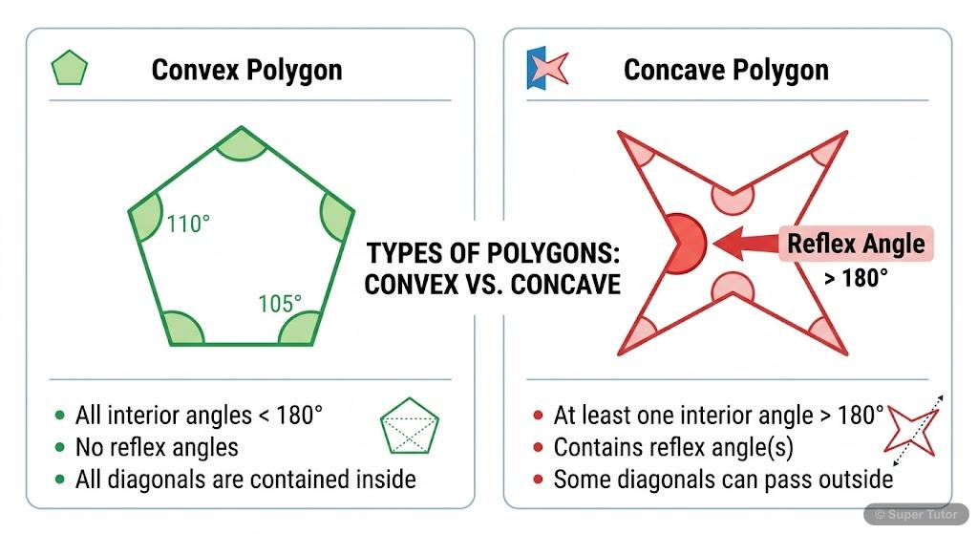

Definition
# Source: AI Source: Provided by: [Data Path: Persons Table -> ID Column: 1, Name_En Column: Motasem Essam] -> From: [ChatGPT] on [7/25/2026]
A polygon is a closed, two-dimensional geometric figure formed by a finite number of straight line segments connected end to end.
The line segments are called sides, and the points where two sides meet are called vertices.
A polygon must:
- Be closed.
- Have straight sides.
- Have at least three sides.
- Have sides that meet only at their endpoints in a standard simple polygon.
Example
A triangle is a polygon because it has:
- 3 straight sides
- 3 vertices
- A closed boundary
A circle is not a polygon because its boundary is curved.

Purpose
# Source: AI Source: Provided by: [Data Path: Persons Table -> ID Column: 1, Name_En Column: Motasem Essam] -> From: [ChatGPT] on [7/25/2026]
Polygons are used to:
- Describe and classify two-dimensional geometric figures.
- Study lengths, angles, areas, and perimeters.
- Model shapes in architecture and engineering.
- Represent regions on maps and diagrams.
- Form the faces of many three-dimensional solids.
- Provide the foundation for more advanced geometry.

Fundamental Elements of a Polygon
# Source: AI Source: Provided by: [Data Path: Persons Table -> ID Column: 1, Name_En Column: Motasem Essam] -> From: [ChatGPT] on [7/25/2026]
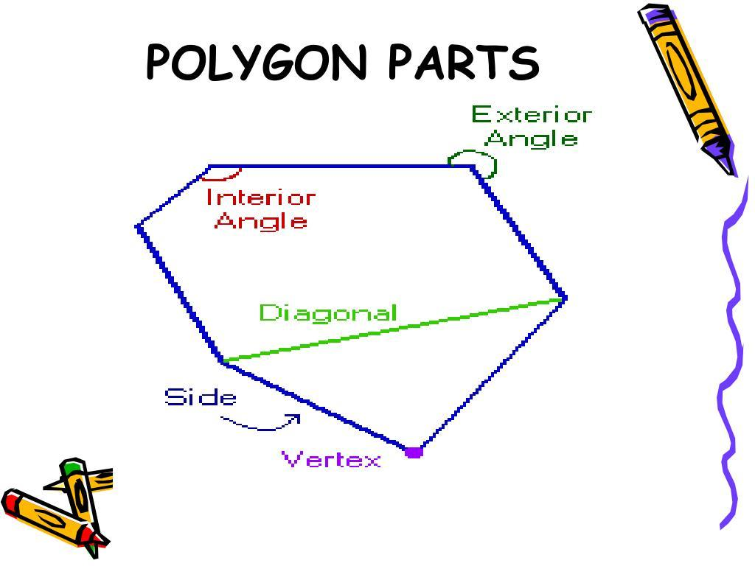
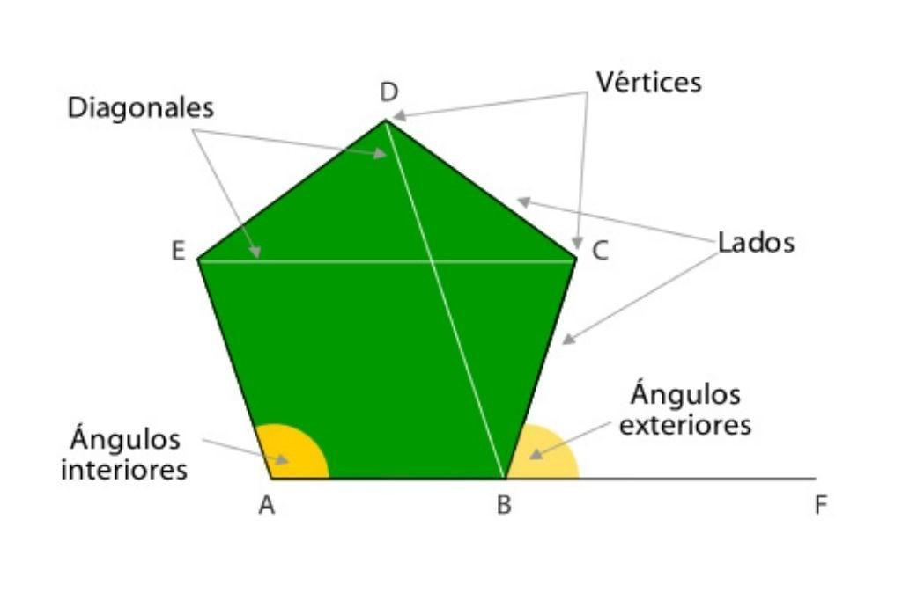
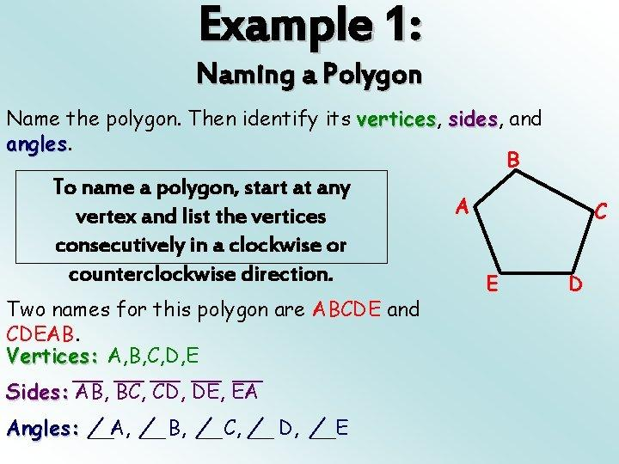
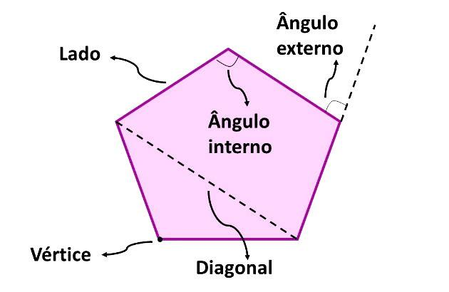
A polygon has several important elements.

1. Side
# Source: AI Source: Provided by: [Data Path: Persons Table -> ID Column: 1, Name_En Column: Motasem Essam] -> From: [ChatGPT] on [7/25/2026]
A side is one of the line segments forming the boundary of the polygon.
For polygon $ABCDE$:
$$\overset{‾}{AB},\overset{‾}{BC},\overset{‾}{CD},\overset{‾}{DE},\overset{‾}{EA}$$
are its five sides.

2. Vertex
# Source: AI Source: Provided by: [Data Path: Persons Table -> ID Column: 1, Name_En Column: Motasem Essam] -> From: [ChatGPT] on [7/25/2026]
A vertex is a point where two sides meet.
For polygon $ABCDE$, the vertices are:
$$A,B,C,D,E$$

3. Interior Angle
# Source: AI Source: Provided by: [Data Path: Persons Table -> ID Column: 1, Name_En Column: Motasem Essam] -> From: [ChatGPT] on [7/25/2026]
An interior angle is an angle formed inside the polygon by two adjacent sides.

4. Exterior Angle
# Source: AI Source: Provided by: [Data Path: Persons Table -> ID Column: 1, Name_En Column: Motasem Essam] -> From: [ChatGPT] on [7/25/2026]
An exterior angle is formed between one side of the polygon and the extension of an adjacent side.

5. Diagonal
# Source: AI Source: Provided by: [Data Path: Persons Table -> ID Column: 1, Name_En Column: Motasem Essam] -> From: [ChatGPT] on [7/25/2026]
A diagonal is a line segment connecting two non-adjacent vertices of a polygon.
For example, in pentagon $ABCDE$:
$$\overset{‾}{AC}$$
is a diagonal.

6. Perimeter
# Source: AI Source: Provided by: [Data Path: Persons Table -> ID Column: 1, Name_En Column: Motasem Essam] -> From: [ChatGPT] on [7/25/2026]
The perimeter is the total length of all the sides.
For a polygon with side lengths $s_{1},s_{2},…,s_{n}$:
$$P=s_{1}+s_{2}+⋯+s_{n}$$

Classification of Polygons by Number of Sides
# Source: AI Source: Provided by: [Data Path: Persons Table -> ID Column: 1, Name_En Column: Motasem Essam] -> From: [ChatGPT] on [7/25/2026]
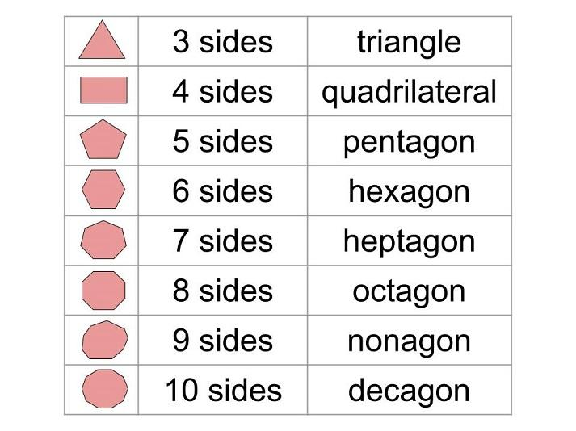
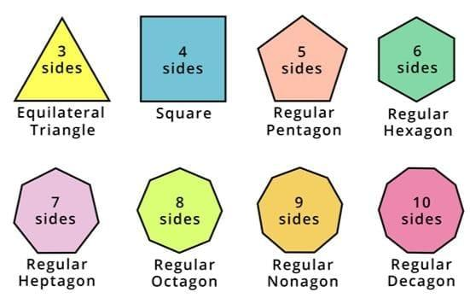
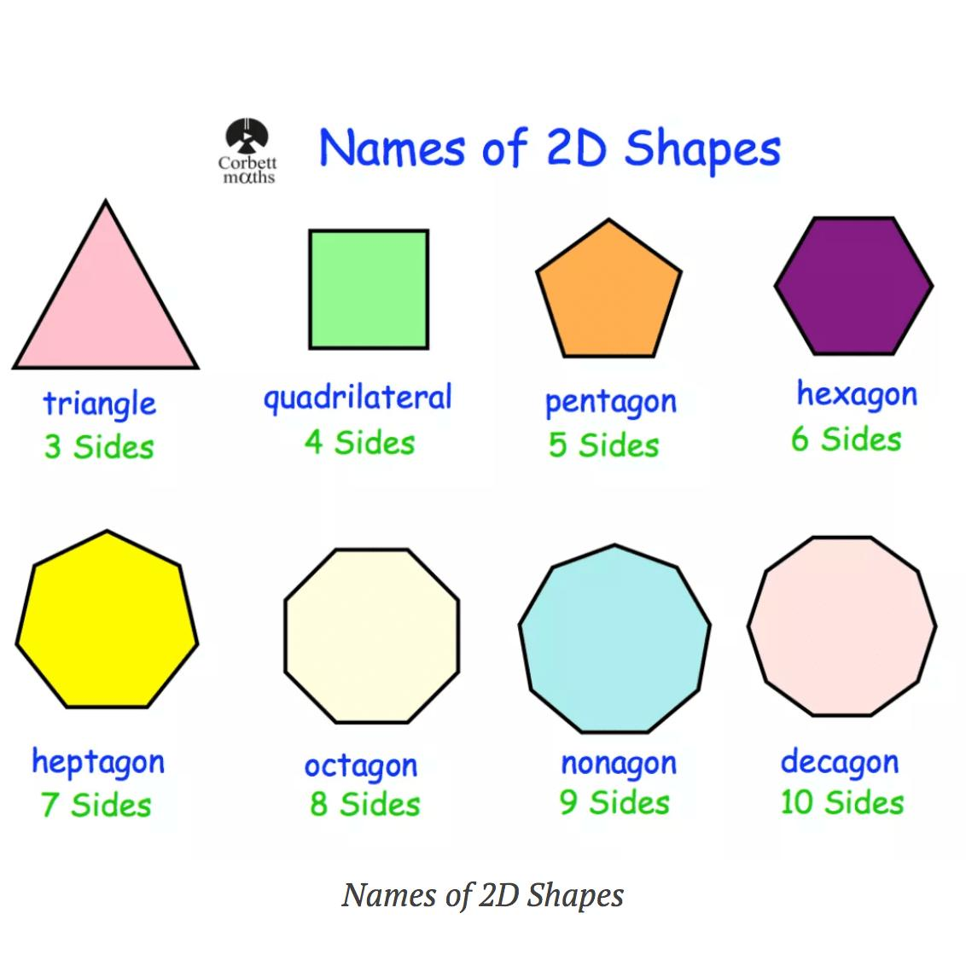
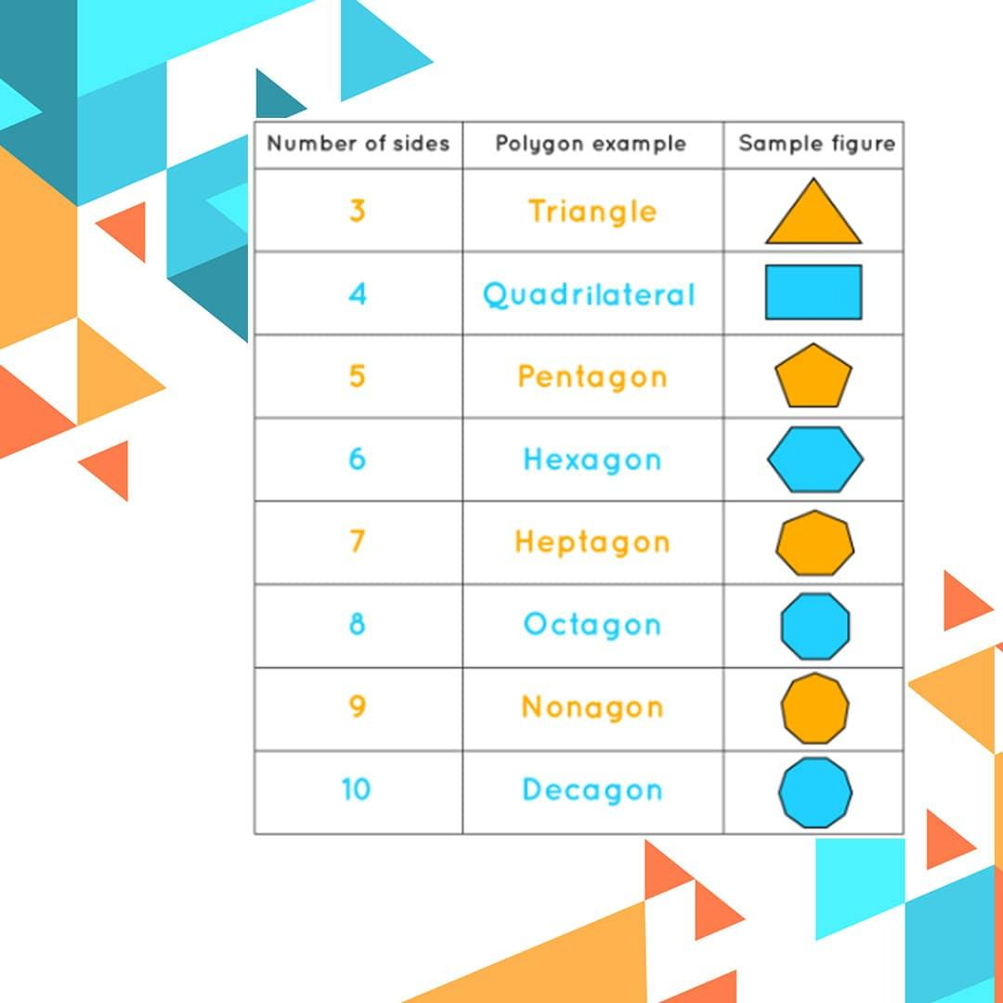
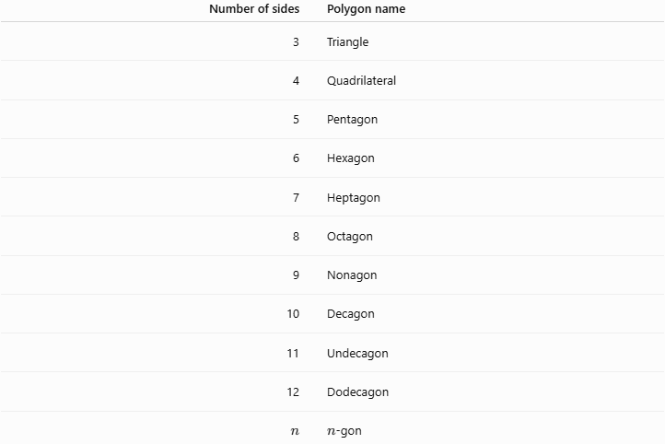
Number of sides | Polygon name
3 | Triangle
4 | Quadrilateral
5 | Pentagon
6 | Hexagon
7 | Heptagon
8 | Octagon
9 | Nonagon
10 | Decagon
11 | Undecagon
12 | Dodecagon
$$n$$ | $n$-gon
Example
A polygon with 8 sides is an octagon.
A polygon with 6 sides is a hexagon.

Classification by Regularity

Regular Polygon
# Source: AI Source: Provided by: [Data Path: Persons Table -> ID Column: 1, Name_En Column: Motasem Essam] -> From: [ChatGPT] on [7/25/2026]
A regular polygon has:
- All sides equal in length.
- All interior angles equal in measure.
Examples include a regular triangle, square, and regular pentagon.
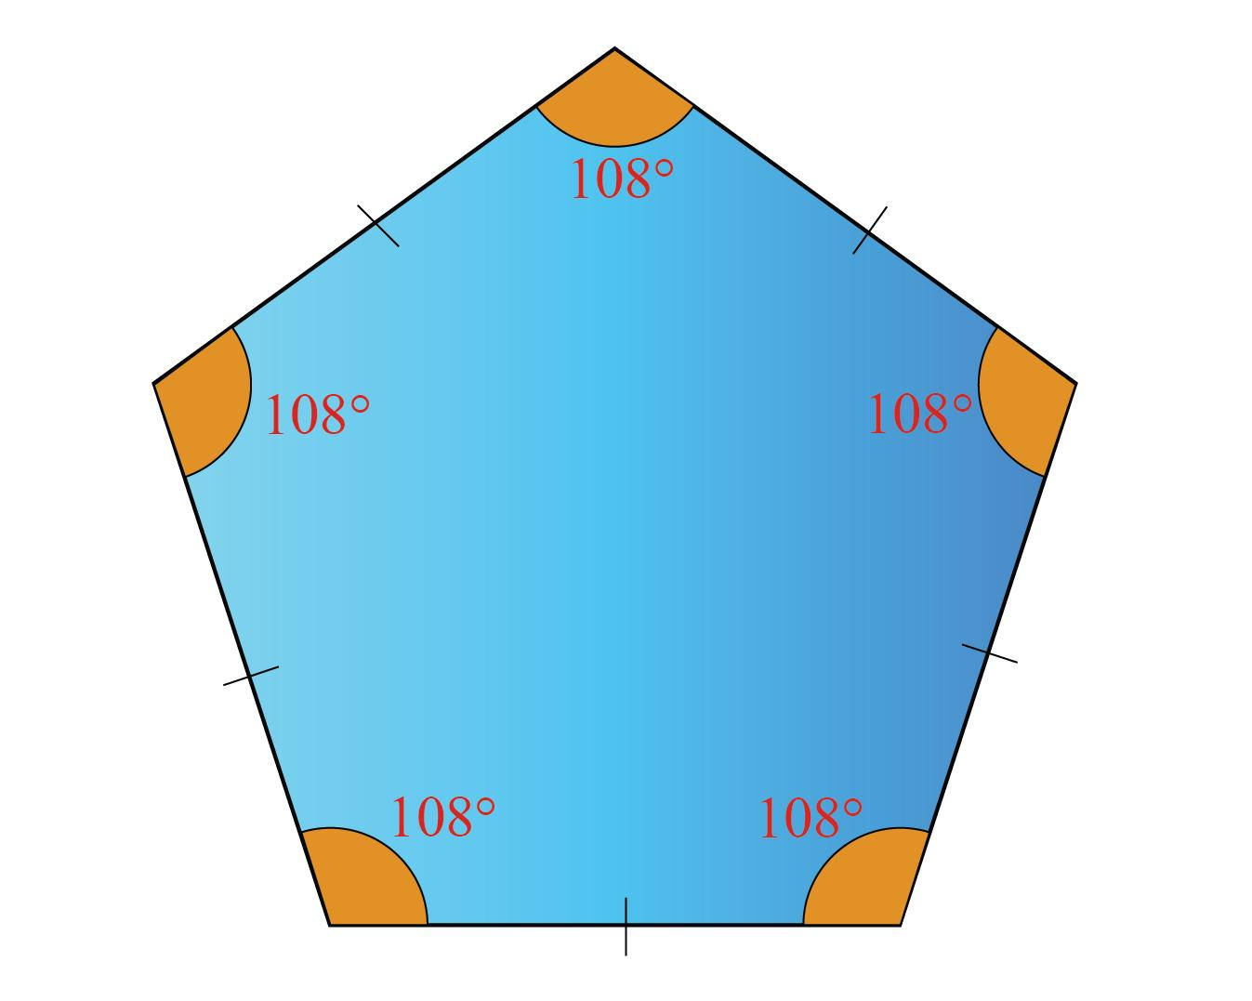
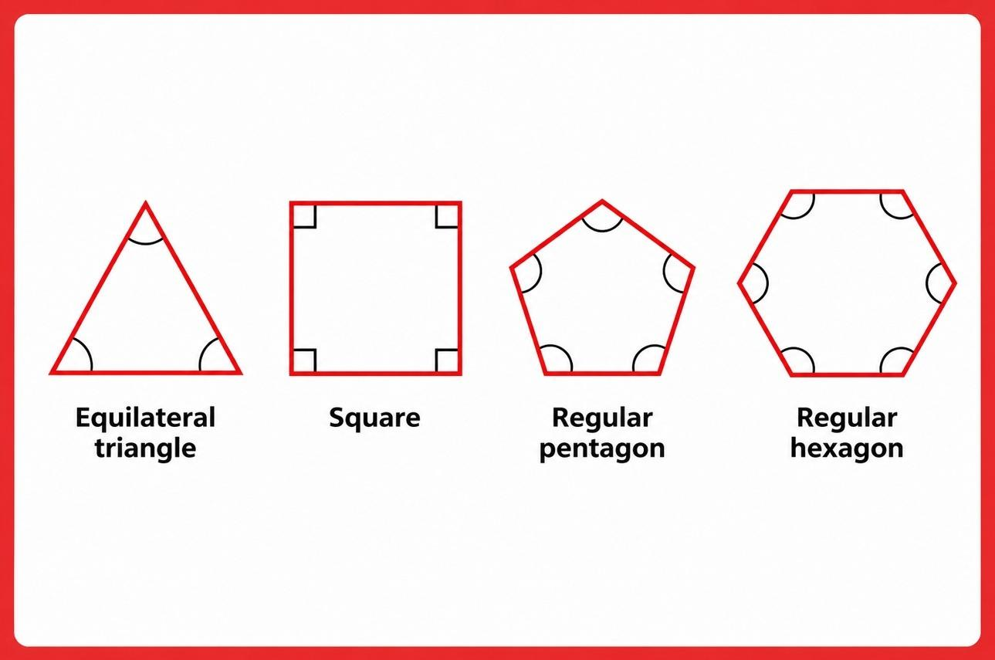
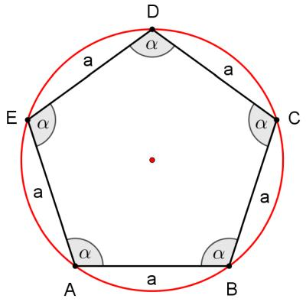
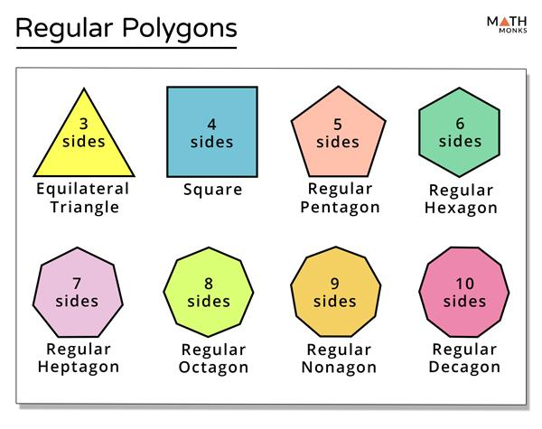
For a regular $n$-gon, each interior angle is:
$$\frac{\left(n-2\right){180}^{∘}}{n}$$
Example
For a regular hexagon:
$$\frac{\left(6-2\right){180}^{∘}}{6}=\frac{{720}^{∘}}{6}={120}^{∘}$$
Therefore, each interior angle is:
$$\boxed{{120}^{∘}}$$

Irregular Polygon
# Source: AI Source: Provided by: [Data Path: Persons Table -> ID Column: 1, Name_En Column: Motasem Essam] -> From: [ChatGPT] on [7/25/2026]
An irregular polygon does not have all sides and angles equal.
For example, a pentagon with different side lengths or different angle measures is irregular.

Classification by Shape
Convex Polygon
A convex polygon has all its interior angles less than:
$${180}^{∘}$$
No diagonal lies outside the polygon.
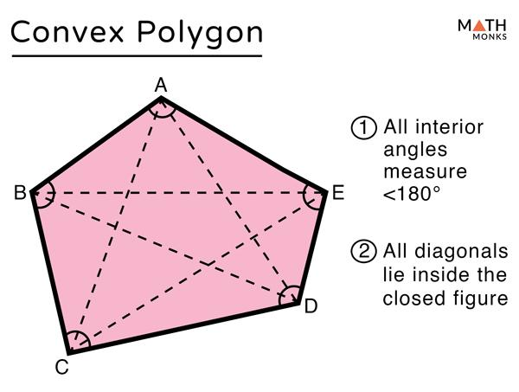
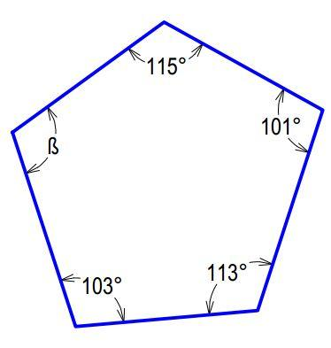
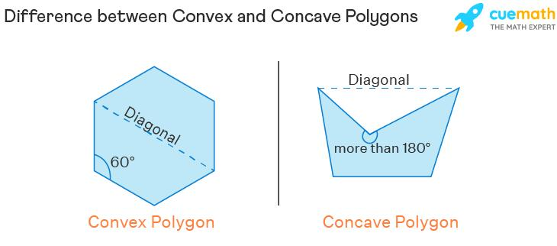

Concave Polygon
# Source: AI Source: Provided by: [Data Path: Persons Table -> ID Column: 1, Name_En Column: Motasem Essam] -> From: [ChatGPT] on [7/25/2026]
A concave polygon has at least one interior angle greater than:
$${180}^{∘}$$
At least one diagonal lies partly outside the polygon.
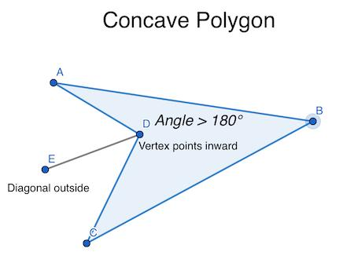
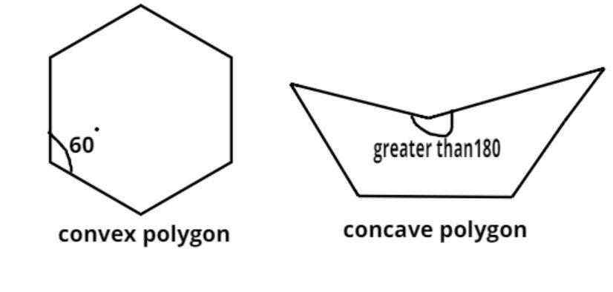
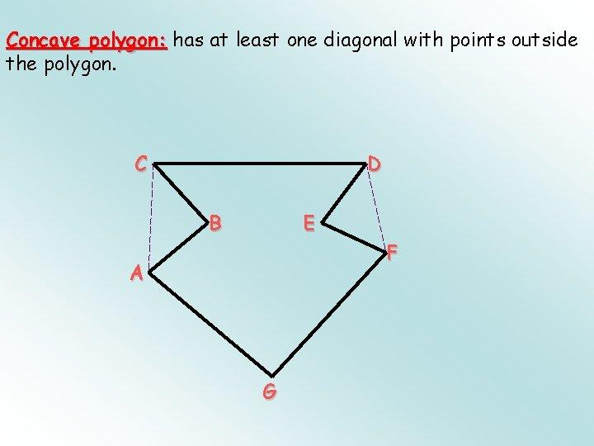
Comparison
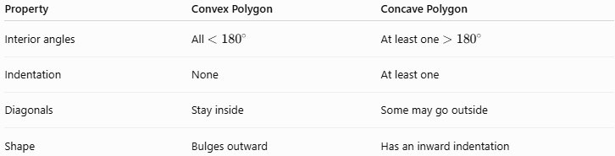
Property | Convex Polygon | Concave Polygon
Interior angles | All $<{180}^{∘}$ | At least one $>{180}^{∘}$
Indentation | None | At least one
Diagonals | Stay inside | Some may go outside
Shape | Bulges outward | Has an inward indentation

Interior Angle Sum
# Source: AI Source: Provided by: [Data Path: Persons Table -> ID Column: 1, Name_En Column: Motasem Essam] -> From: [ChatGPT] on [7/25/2026]
The sum of the interior angles of an $n$-sided polygon is:
$$\boxed{S=\left(n-2\right){180}^{∘}}$$
Example: Pentagon
A pentagon has $n=5$.
$$S=\left(5-2\right){180}^{∘} \\ S=3\left({180}^{∘}\right) \\ \boxed{S={540}^{∘}}$$
Therefore, the interior angles of any pentagon add up to ${540}^{∘}$.

Exterior Angle Sum
# Source: AI Source: Provided by: [Data Path: Persons Table -> ID Column: 1, Name_En Column: Motasem Essam] -> From: [ChatGPT] on [7/25/2026]
For any simple convex polygon, the sum of one exterior angle at each vertex is:
$$\boxed{{360}^{∘}}$$
Example
For a regular octagon:
$$\text{Each exterior angle}=\frac{{360}^{∘}}{8}={45}^{∘}$$
Therefore:
$$\boxed{{45}^{∘}}$$

Number of Diagonals
# Source: AI Source: Provided by: [Data Path: Persons Table -> ID Column: 1, Name_En Column: Motasem Essam] -> From: [ChatGPT] on [7/25/2026]
For an $n$-sided polygon, the number of diagonals is:
$$\boxed{D=\frac{n\left(n-3\right)}{2}}$$
Example: Hexagon
A hexagon has $n=6$.
$$D=\frac{6\left(6-3\right)}{2} \\ D=\frac{18}{2} \\ \boxed{9}$$
A hexagon has 9 diagonals.

Triangulation of a Polygon
# Source: AI Source: Provided by: [Data Path: Persons Table -> ID Column: 1, Name_En Column: Motasem Essam] -> From: [ChatGPT] on [7/25/2026]
A polygon can be divided into triangles by drawing diagonals from one vertex.
For an $n$-sided polygon, the number of triangles formed is:
$$\boxed{n-2}$$
Example: Pentagon
$$5-2=3$$
A pentagon can be divided into 3 triangles.
This explains the interior-angle-sum formula:
$$\left(n-2\right)\left({180}^{∘}\right)$$

Regular Polygon Formulas
# Source: AI Source: Provided by: [Data Path: Persons Table -> ID Column: 1, Name_En Column: Motasem Essam] -> From: [ChatGPT] on [7/25/2026]
For a regular $n$-gon:
Interior Angle Sum
$$S=\left(n-2\right){180}^{∘}$$
Each Interior Angle
$$\boxed{I=\frac{\left(n-2\right){180}^{∘}}{n}}$$
Each Exterior Angle
$$\boxed{E=\frac{{360}^{∘}}{n}}$$
Perimeter
If each side has length $s$:
$$\boxed{P=ns}$$
Number of Diagonals
$$\boxed{D=\frac{n\left(n-3\right)}{2}}$$

Examples

Example 1: Identify a Polygon
# Source: AI Source: Provided by: [Data Path: Persons Table -> ID Column: 1, Name_En Column: Motasem Essam] -> From: [ChatGPT] on [7/25/2026]
A closed figure has 7 straight sides.
Solution:
A polygon with 7 sides is a:
$$\boxed{\text{Heptagon}}$$

Example 2: Interior Angle Sum of an Octagon
# Source: AI Source: Provided by: [Data Path: Persons Table -> ID Column: 1, Name_En Column: Motasem Essam] -> From: [ChatGPT] on [7/25/2026]
An octagon has 8 sides.
$$S=\left(8-2\right){180}^{∘} \\ S=6\left({180}^{∘}\right) \\ \boxed{S={1080}^{∘}}$$

Example 3: Each Interior Angle of a Regular Pentagon
# Source: AI Source: Provided by: [Data Path: Persons Table -> ID Column: 1, Name_En Column: Motasem Essam] -> From: [ChatGPT] on [7/25/2026]
$$I=\frac{\left(5-2\right){180}^{∘}}{5} \\ I=\frac{{540}^{∘}}{5} \\ \boxed{I={108}^{∘}}$$

Example 4: Perimeter
# Source: AI Source: Provided by: [Data Path: Persons Table -> ID Column: 1, Name_En Column: Motasem Essam] -> From: [ChatGPT] on [7/25/2026]
A quadrilateral has side lengths:
$$5, 7, 8, 10$$
Therefore:
$$P=5+7+8+10 \\ \boxed{P=30}$$

Example 5: Number of Diagonals
# Source: AI Source: Provided by: [Data Path: Persons Table -> ID Column: 1, Name_En Column: Motasem Essam] -> From: [ChatGPT] on [7/25/2026]
Find the number of diagonals in a decagon.
$$D=\frac{10\left(10-3\right)}{2} \\ D=\frac{10\left(7\right)}{2} \\ \boxed{D=35}$$

Important Properties of Polygons
# Source: AI Source: Provided by: [Data Path: Persons Table -> ID Column: 1, Name_En Column: Motasem Essam] -> From: [ChatGPT] on [7/25/2026]
- A polygon is a closed figure.
- Its boundary consists of straight line segments.
- It has at least three sides.
- The number of sides equals the number of vertices.
- The number of interior angles equals the number of sides.
- The interior-angle sum is:
$$\left(n-2\right){180}^{∘}$$
- The exterior-angle sum of a convex polygon is:
$${360}^{∘}$$
- The number of diagonals is:
$$\frac{n\left(n-3\right)}{2}$$
- A regular polygon has equal sides and equal interior angles.
- A concave polygon has at least one interior angle greater than ${180}^{∘}$.

Polygon and Triangle
# Source: AI Source: Provided by: [Data Path: Persons Table -> ID Column: 1, Name_En Column: Motasem Essam] -> From: [ChatGPT] on [7/25/2026]
A triangle is the simplest polygon because it has the minimum possible number of sides.
$$\boxed{3\text{ sides}}$$
Every polygon with more than three sides can be divided into triangles.

Polygon and Quadrilateral
# Source: AI Source: Provided by: [Data Path: Persons Table -> ID Column: 1, Name_En Column: Motasem Essam] -> From: [ChatGPT] on [7/25/2026]
A quadrilateral is a special type of polygon with exactly four sides.
Examples include:
- Square
- Rectangle
- Rhombus
- Parallelogram
- Trapezoid
- Kite
Thus:
$$\boxed{\text{Every quadrilateral is a polygon}}$$
but:
$$\boxed{\text{Not every polygon is a quadrilateral}}$$

Relationship with Related Concepts
# Source: AI Source: Provided by: [Data Path: Persons Table -> ID Column: 1, Name_En Column: Motasem Essam] -> From: [ChatGPT] on [7/25/2026]
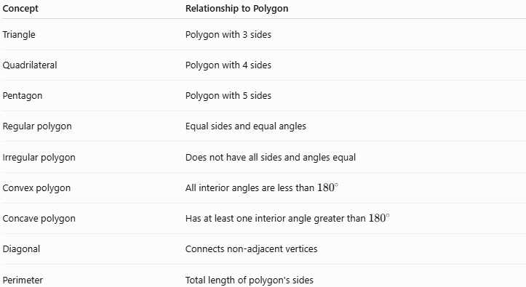
Concept | Relationship to Polygon
Triangle | Polygon with 3 sides
Quadrilateral | Polygon with 4 sides
Pentagon | Polygon with 5 sides
Regular polygon | Equal sides and equal angles
Irregular polygon | Does not have all sides and angles equal
Convex polygon | All interior angles are less than ${180}^{∘}$
Concave polygon | Has at least one interior angle greater than ${180}^{∘}$
Diagonal | Connects non-adjacent vertices
Perimeter | Total length of polygon's sides

Polygon vs Circle
# Source: AI Source: Provided by: [Data Path: Persons Table -> ID Column: 1, Name_En Column: Motasem Essam] -> From: [ChatGPT] on [7/25/2026]
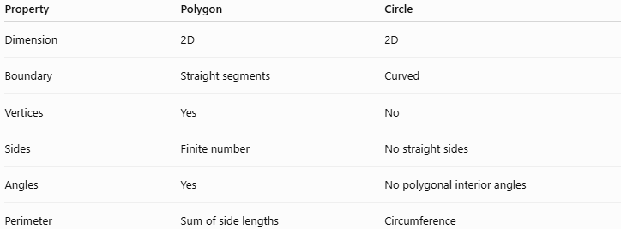
Property | Polygon | Circle
Dimension | 2D | 2D
Boundary | Straight segments | Curved
Vertices | Yes | No
Sides | Finite number | No straight sides
Angles | Yes | No polygonal interior angles
Perimeter | Sum of side lengths | Circumference

Real-World Applications
# Source: AI Source: Provided by: [Data Path: Persons Table -> ID Column: 1, Name_En Column: Motasem Essam] -> From: [ChatGPT] on [7/25/2026]
Polygons appear throughout everyday life:
- Architecture: floor plans, windows, buildings.
- Engineering: mechanical parts and structural designs.
- Road signs: triangular, rectangular, octagonal signs.
- Computer graphics: 3D models are commonly constructed from polygonal faces.
- Maps: geographic regions can be approximated using polygons.
- Construction: polygonal layouts and surfaces.
- Art and design: geometric patterns and tessellations.
- Surveying: land boundaries can be represented by polygons.

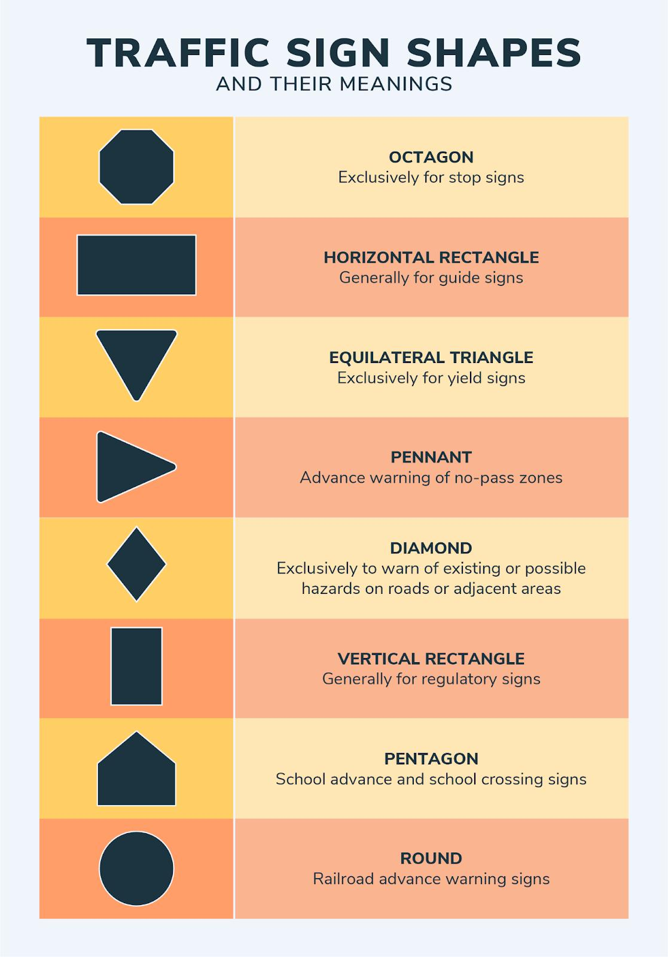
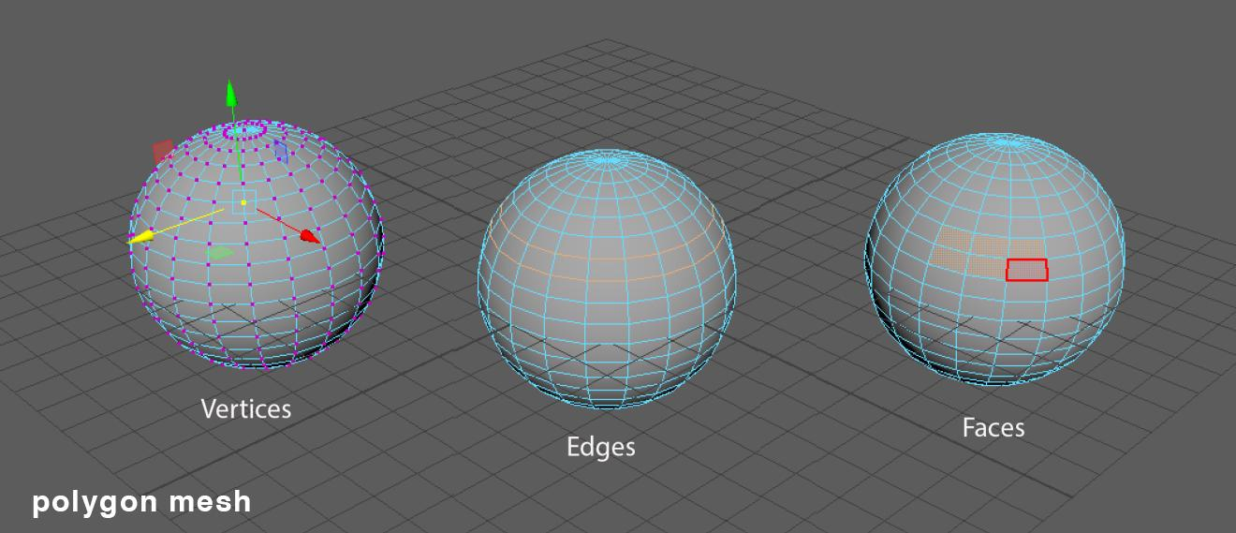
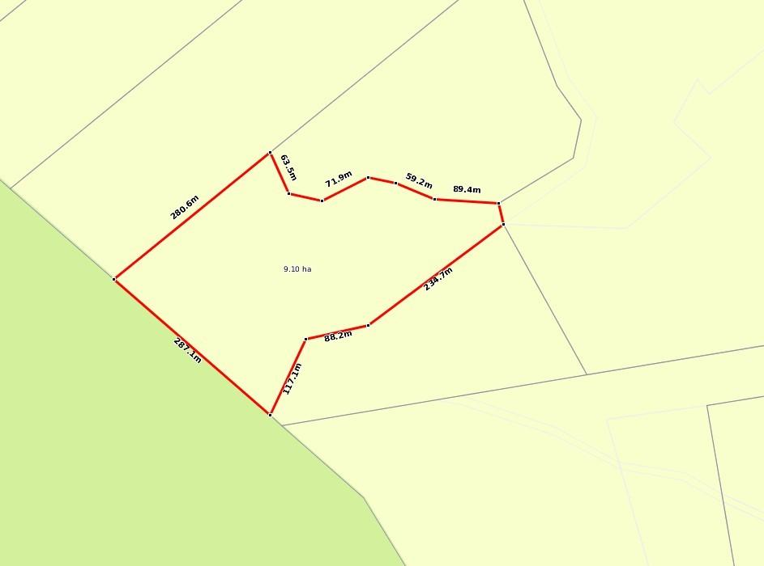

Advantages
# Source: AI Source: Provided by: [Data Path: Persons Table -> ID Column: 1, Name_En Column: Motasem Essam] -> From: [ChatGPT] on [7/25/2026]
- Provides a simple mathematical representation of many shapes.
- Easy to classify according to the number of sides.
- Allows systematic calculation of angles, perimeter, and diagonals.
- Can approximate complex curved shapes using many small sides.
- Fundamental to geometry, computer graphics, CAD, and engineering.

Limitations
# Source: AI Source: Provided by: [Data Path: Persons Table -> ID Column: 1, Name_En Column: Motasem Essam] -> From: [ChatGPT] on [7/25/2026]
- A standard polygon cannot have curved sides.
- Polygon formulas depend on the polygon being properly defined.
- Irregular polygons may require more complicated calculations.
- Polygonal approximations of curved objects are not perfectly curved.

Key Points
# Source: AI Source: Provided by: [Data Path: Persons Table -> ID Column: 1, Name_En Column: Motasem Essam] -> From: [ChatGPT] on [7/25/2026]
- A polygon is a closed 2D figure made from straight line segments.
- The segments are called sides.
- Their meeting points are called vertices.
- Polygons have at least 3 sides.
- They are named according to their number of sides.
- Polygons can be regular or irregular.
- They can also be convex or concave.
- Interior-angle sum:
$$\boxed{\left(n-2\right){180}^{∘}}$$
- Exterior-angle sum for a convex polygon:
$$\boxed{{360}^{∘}}$$
- Number of diagonals:
$$\boxed{\frac{n\left(n-3\right)}{2}}$$
- A triangle is the simplest polygon.
- A quadrilateral is a polygon with four sides.

Conclusion
# Source: AI Source: Provided by: [Data Path: Persons Table -> ID Column: 1, Name_En Column: Motasem Essam] -> From: [ChatGPT] on [7/25/2026]
A polygon is a fundamental plane-geometric figure consisting of a finite number of straight line segments forming a closed boundary. Polygons can be classified by their number of sides, regularity, and shape. Their sides, vertices, angles, diagonals, perimeter, and area provide the foundation for studying many other concepts in Plane Geometry.

